CSS-HTML Exam —-4bhrs

1. Design a form with input fields for name, email, and message.

**Program:**

<body>

        <h1>Registration</h1>

        <form>

            <label for="First Name:">First name</label>

            <input type="text" name="first name" required><br><br>

            <label for="Email:">Email</label>

            <input type="text" name="email" required><br><br>

            <label for="Message">Message</label><br>

            <textarea name="message" rows="4" cols="30">Message</textarea><br><br>

            <input type="Submit" value="Submit">

        </form>

  </body>

**Output:**

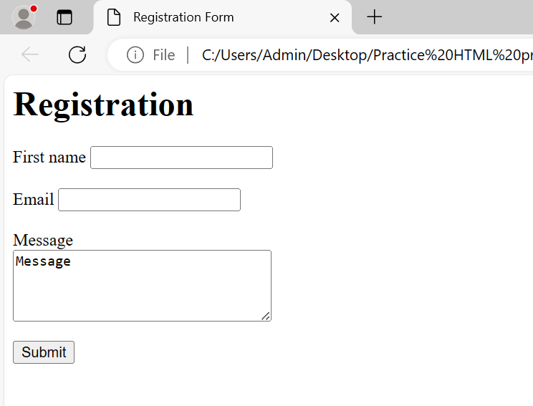

1. Create a three-column layout using CSS grid or flexbox.

**Program: (flex box)**

<style>

            #Employee{

                width: 300px;

                height: 100px;

                display: flex;

                color: rgb(13, 175, 32);

            }

            div{

                border: 3px solid;

                border-color: black;

            }

   </style>

    </head>

    <body>

        <h1>Employee details</h1>

        <div id="Employee">

            <div class="Employee1">Employee Name</div>

            <div class="Employee2">Employee salary</div>

            <div class="Employee3">Employee Address</div>

        </div>

    </body>

**Output:**

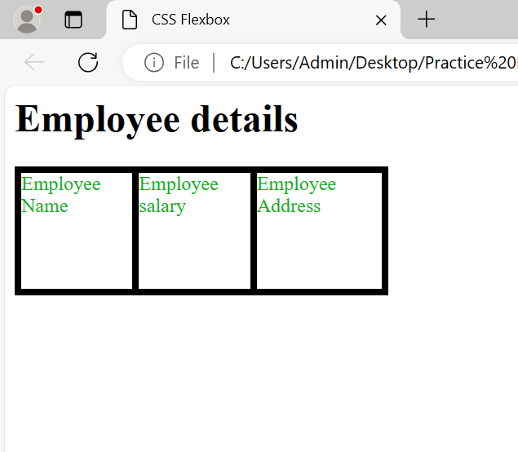

1. Make a responsive website that adjusts its layout for different screen sizes.

**Program:**

<style>

           .title{

            font-size: 5vw;

            font-family: 'Courier New', Courier, monospace;

            color: red;

            text-align: center;

            text-decoration-line: underline;

           }

           h2,h3,h4{

            border-style:double;

            width:300px;

           }

           .container{

            display:flexbox;

           }

   </style>

    </head>

    <body>

        <h1 class="title">Responsive Website layout</h1>

        <div class="container">

        <h2>Chrome Website</h2>

        <h3>This is a Chrome Website</h3>

        <h4>Footer content</h4>

    </div>

    </body>

**Output:**

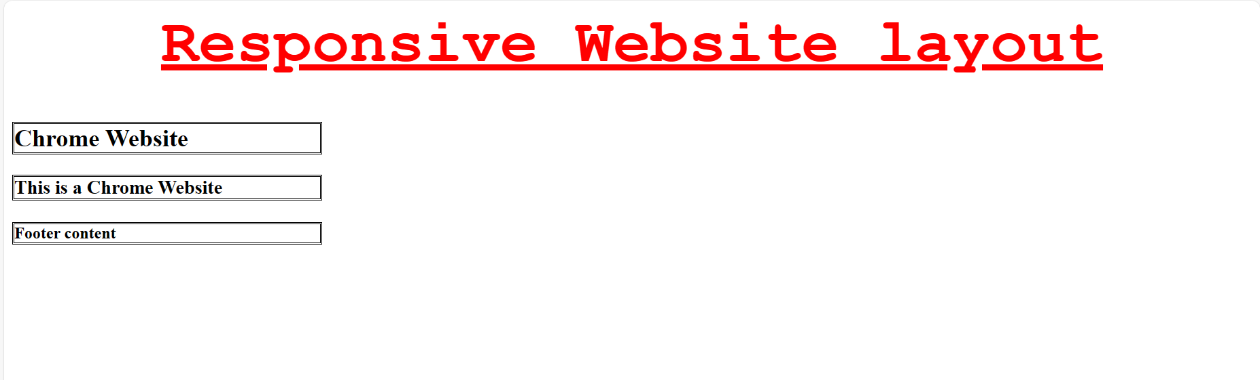

1. Style a button to change its appearance when hovered over.

**Program:**

<style>

           .hover-button{

            background-color: lightskyblue;

            text-align: center;

            display: inline-block;

            font-size: 16px;

            cursor: pointer;

           }

 </style>

    </head>

    <body>

        <h1>Button</h1>

        <button class="hover-button">Hover Over Me</button>

        </body>

**Output:**

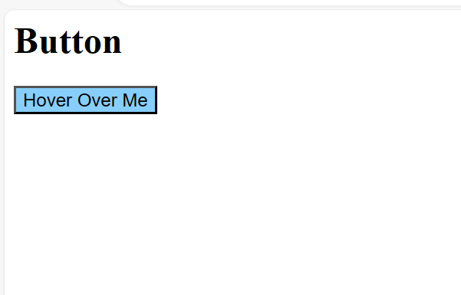

1. Create a dropdown menu using HTML and CSS.

**Program:**

<style>

          body{

            background-color: lightblue

          }

          .Country{

            background-color: lightcoral;

          }

          input{

            background-color: rgb(193, 227, 124);

          }

  </style>

    </head>

    <body>

        <h1>Dropdown-menu</h1>

        <select class="Country" name="Country" id="Country">

            <option value="India">India</option>

            <option value="China">China</option>

            <option value="Nepal">Nepal</option>

            <option value="America">America</option>

            </div>

        </select><br><br>

        <input type="Submit" value="Submit">

    </body>

**Output:**

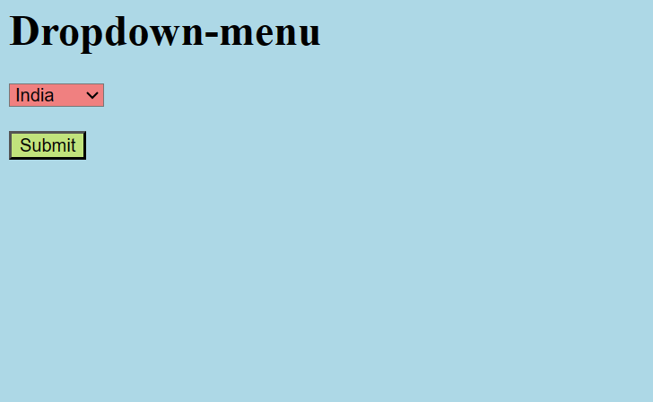

1. Build a simple slideshow using HTML, CSS, and JavaScript.

**Program:**

<!DOCTYPE html>

<html>

  <head>

    <style>

  .box{

  width: 400px;

  height: 300px;

  position: relative;

  }

  .left, .right {

  position: absolute;

  top: 50%;

  width: 10px;

  padding: 16px;

  color: rgb(171, 171, 49);

  background-color: rgb(237, 159, 3);

  }

  .right {

  right: 0;

  border-radius: 3px 0 0 3px;

  }

  .left:hover, .right:hover {

  background-color: rgba(25, 42, 198, 0.8);

  }

    </style>

  </head>

  <body>

    <h1>Slide show</h1>

    <div class="box">

      <div class="mySlides fade">

        <img src="Buddha.jpg" style="width:100%">

      </div>

    <div class="mySlides fade">

        <img src="Charminar.jpg" style="width:100%">

      </div>

      <div class="mySlides fade">

        <img src="Roseflower.jpg" style="width:100%">

      </div>

      <a class="left" onclick="plusSlides(-1)">❮</a>

      <a class="right" onclick="plusSlides(1)">❯</a>

    </div>

  <script>

  let slideIndex = 1;

  showSlides(slideIndex);

  function plusSlides(n) {

  showSlides(slideIndex += n);

  }

  function currentSlide(n) {

  showSlides(slideIndex = n);

  }

  function showSlides(n) {

  let i;

  let slides = document.getElementsByClassName("mySlides");

  let dots = document.getElementsByClassName("dot");

  if (n > slides.length) {slideIndex = 1}

  if (n < 1) {slideIndex = slides.length}

  for (i = 0; i < slides.length; i++) {

    slides[i].style.display = "none";

  }

  slides[slideIndex-1].style.display = "block";

  }

  </script>

  </body>

</html>

**Output:**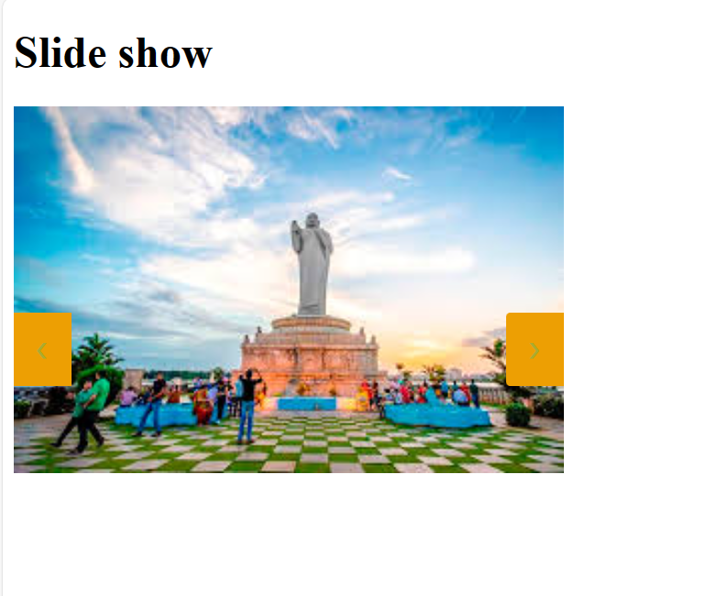

1. Design a pricing table with multiple plans using HTML and CSS.

**Program:**

<title>Pricing Table</title>

        <link rel="stylesheet" href="Styles.css">

    </head>

    <body>

        <h1>Pricing-table Prices</h1>

        <div class="Pricing-table">

        <div class="plan">

            <h2>Basic</h2>

            <p class="price">$10/month</p>

            <ul>

                <li>2GB storage</li>

                <li>10 accounts</li>

                <li>50GB Bandwidth</li>

            </ul>

            <button>Sign Up</button>

        </div>

        <div class="plan featured">

            <h2>Standard</h2>

            <p class="price">$49/month</p>

            <ul>

                <li>20GB storage</li>

                <li>20 accounts</li>

                <li>500GB Bandwidth</li>

                <li>24/7 support</li>

            </ul>

            <button>Sign Up</button>

        </div>

        <div class="plan">

            <h3>Premium</h3>

            <p class="price">$99/month</p>

            <ul>

                <li>100GB storage</li>

                <li>100 accounts</li>

                <li>500GB Bandwidth</li>

                <li>24/7 support</li>

            </ul>

            <button>Sign Up</button>

        </div>

    </div>

    </body>

**CSS:**

.Pricing-table{

    display: flex;

    margin-top: 50px;

    justify-content: space-around;

}

.plan{

    background-color: bisque;

    padding: 20px;

    text-align: center;

}

**Output:**

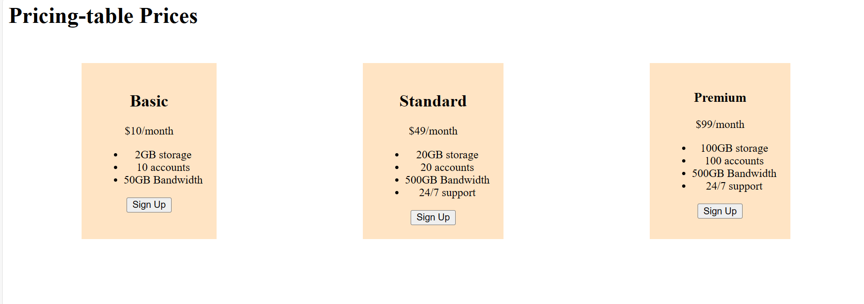

1. Make a sticky navigation bar that stays at the top of the page when scrolling.

**Program:**

<title>Sticky Navigation Bar</title>

        <link rel="stylesheet" href="Styles.css">

    </head>

    <body>

        <h1>Sticky Navigation Bar</h1>

        <div class="navbar">

            <nav>

            <a href="#home">Home</a>

            <a href="#about">About</a>

            <a href="#services">Services</a>

            <a href="#contact">Contact</a>

            </nav>

            <p>"Home" could lead to the main landing page of the website."About" could lead to a page with information about the website or organization.

                "Services" could lead to a page listing the services offered by the website or organization.

                "Contact" could lead to a page with contact information or a contact form for users to get in touch.

            </p>

        </div>

    </body>

**Output:**

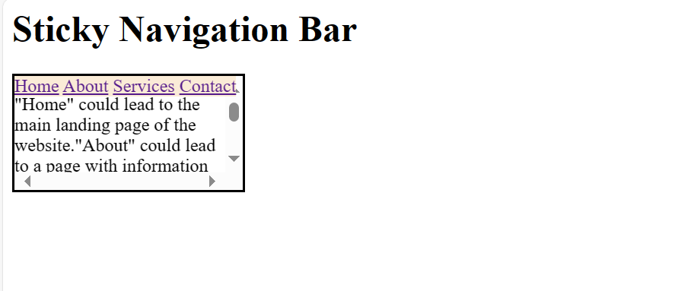

1. Implement a hover effect on images that enlarges them slightly.

**Program:**

<title>Image Hover effect</title>

        <link rel="stylesheet" href="Styles.css">

    </head>

    <body>

        <h1>Image Hover effect</h1>

        <div class="image-container">

            <img src="girl.jpg" alt="Image">

        </div>

    </body>

**CSS:**

.image-container{

    width: 500px;

    overflow: hidden;

}

.image-container img {

    display: block;

    width: 100%;

    height: auto;

    transition: transform 0.5s;

}

.image-container img:hover {

    transform: scale(1.1);

}

**Output:**

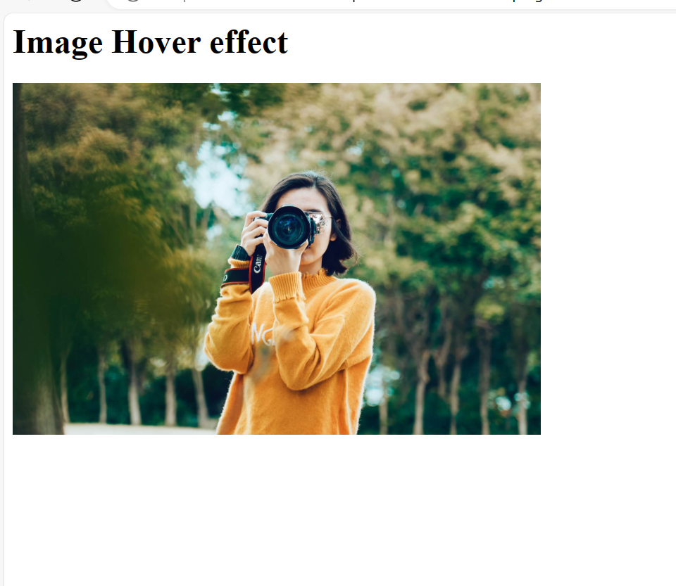

1. Create a login form with HTML and style it using CSS.

**Program:**

<body>

    <div class="login">

        <h2>Login</h2>

        <form>

            <label for="username">Username:</label><br>

            <input type="text" id="username" name="username" required><br><br>

            <label for="password">Password:</label><br>

            <input type="password" id="password" name="password" required><br><br>

            <input type="submit" value="Login">

        </form>

    </div>

</body>

**CSS:**

body{

    background-color: antiquewhite;

    font-family: Arial, Helvetica, sans-serif;

}

.login{

    width: 300px;

    margin: 100px auto;

    border-radius: 5px;

    background-color: rgb(161, 220, 239);

}

h2{

    text-align: center;

    margin-bottom: 20px;

}

input{

    cursor: pointer;

}

**Output:**

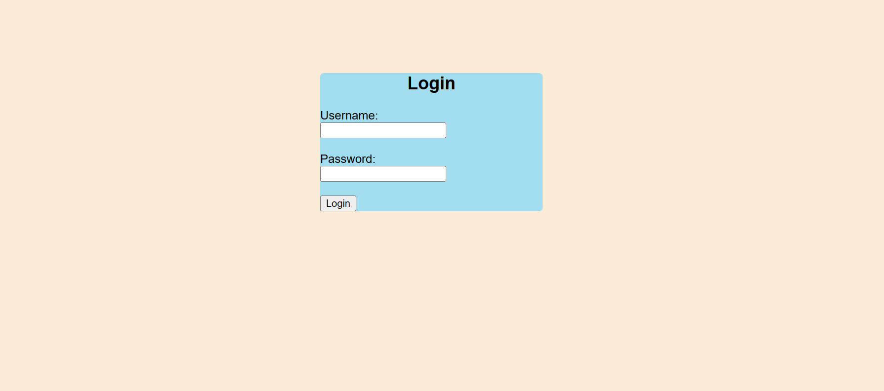

1. Build a responsive gallery that displays images in a grid format.

**Program:**

**Html:**

<body>

    <h1>Images in Grid format</h1>

    <div class="gallery">

        <div class="gallery-item">

            <img src="girl.jpg" alt="girl">

        </div>

        <div class="gallery-item">

            <img src="Charminar.jpg" alt="Charminar">

        </div>

        <div class="gallery-item">

            <img src="Buddha.jpg" alt="Buddha">

        </div>

    </div>

</body>

**CSS:**

.gallery{

    display: grid;

    padding: 10px;

}

img{

    height: 200px;

    width: 200px;

}

**Output:**

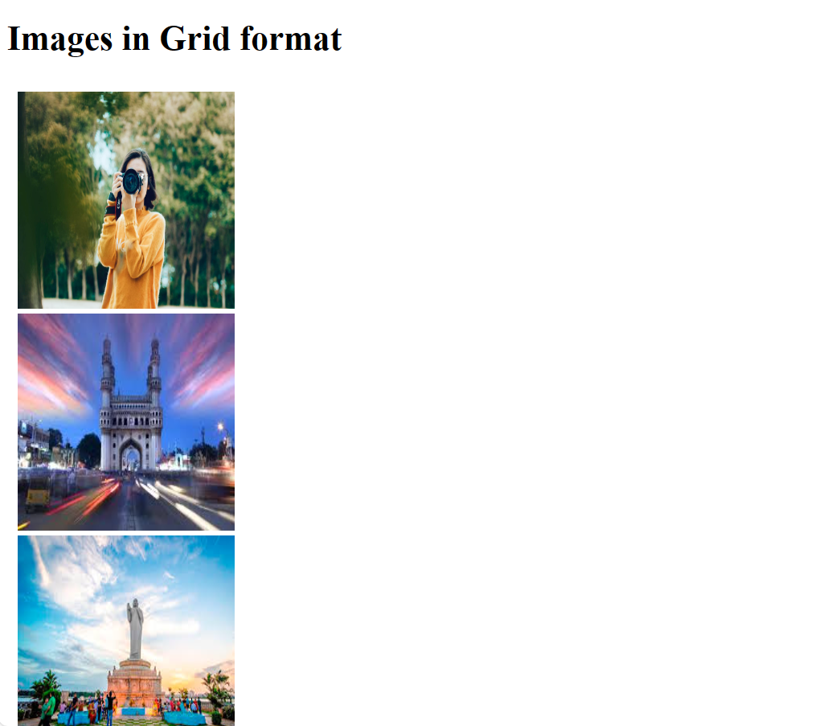

1. Style text to have different fonts, sizes, and colors on the same page.

**Program:**

<style>

        h1{

            color: blue;

            font-size: 80px;

        }

        .font1{

            font-family: 'Times New Roman', Times, serif;

            font-weight: bold;

            font-size: 50px;

            color: orange;

        }

        .font2{

            font-family: Arial, Helvetica, sans-serif;

            font-weight: bolder;

            font-size: 30px;

            color: green;

        }

    </style>

  </head>

  <body>

      <h1>Styled Text</h1>

      <p class="font1">This is font1</p>

      <p class="font2">This is font2</p>

  </body>

**Output:**

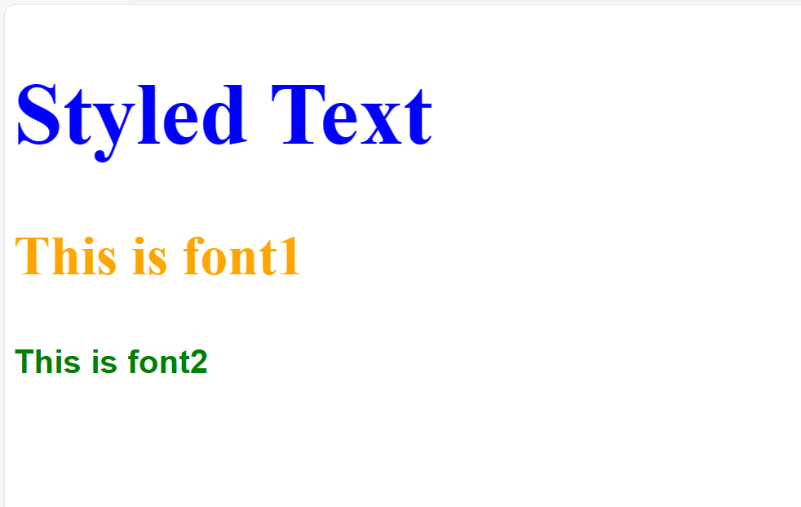

1. Design a footer that stays at the bottom of the page, regardless of content height.

**Program:**

<!DOCTYPE html>

<html>

    <head>

        <style>

            body{

                background-image: url(Buddha.jpg);

            }

            div{

                background-color: rgb(209, 230, 96);

                border: 3px solid;

                height: 300px;

                width: 600px;

                overflow: scroll;

            }

            footer{

                position: sticky;

                background-color: rgb(210, 148, 42);

            }

        </style>

    </head>

    <body>

       <h1>Footer</h1>

       <div>

            <h3>Hyderabad</h3>

        <p>Hyderabad is a city in the southern part of India, located in the state of Telangana. It is known for its rich history, culture, and architecture.One of the most famous landmarks in Hyderabad is the Charminar, a 16th-century mosque with four grand arches, located in the heart of the old city.The city is home to many historical sites and monuments, including the Golconda Fort<br>

            In recent years, Hyderabad has emerged as a major hub for the IT and technology industry in India, with companies like Microsoft, Google, and Amazon having a presence in the city.

            Tank Bund is a popular promenade in Hyderabad, India, located on the banks of the Hussain Sagar Lake.

            One of the most famous temples is the Birla Mandir, also known as the Lakshmi Narayan Temple, which is located on a hill overlooking the city.</p>

                <footer>

                    Hyderabad,Telangana, 500081.

                </footer>

        </div>

    </body>

</html>

**Output:**

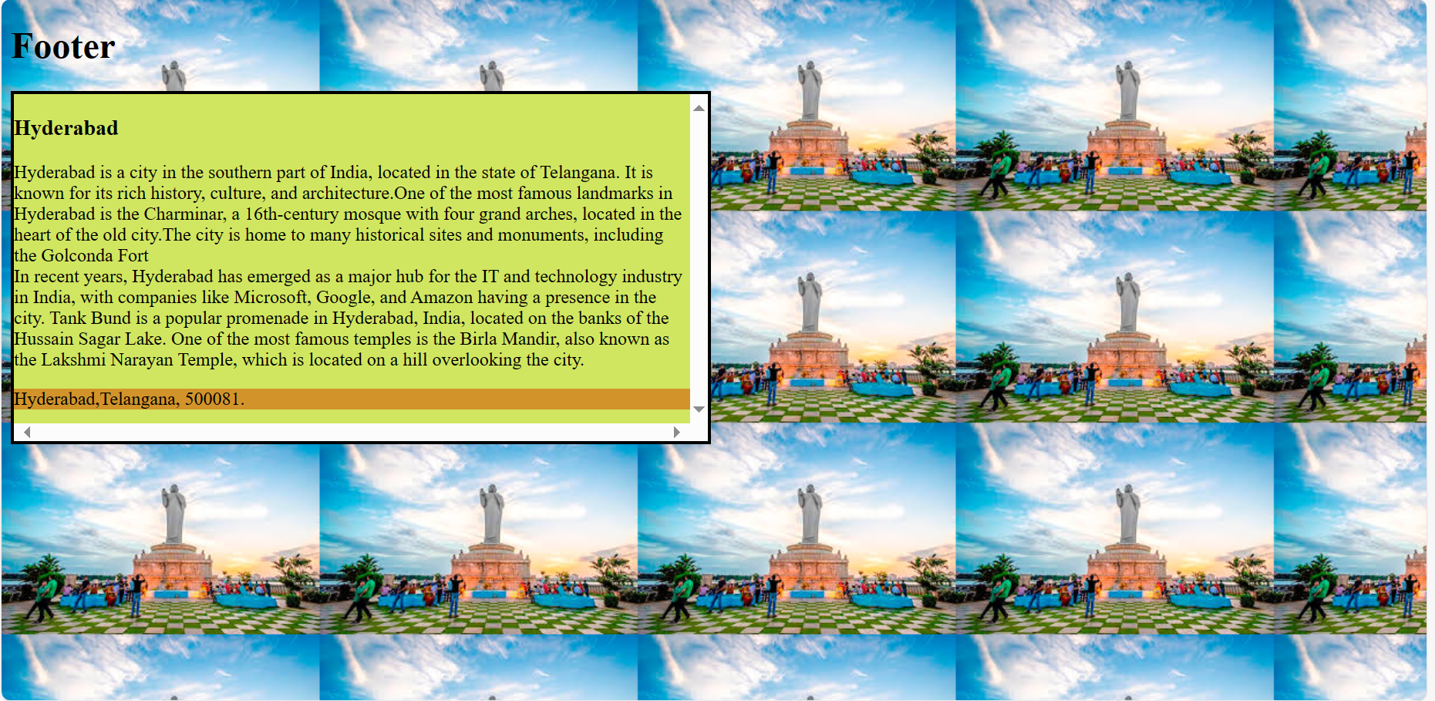

1. Make a horizontal scrolling website using CSS overflow property.

**Program:**

<style>

        p{

            overflow: auto;

            border: 4px solid;

            height: 100px;

            width: 500px;

            white-space: nowrap;

        }

    </style>

</head>

<body>

    <h1>Horizontal Scroll</h1>

    <p>

        To scroll content horizontally within a container that is narrower than the content it contains.

        It provides a way to view the entire content by  scrolling left or right.

        Positioning of an element can be done using the top, right, bottom, and left properties.

    </p>

</body>

**Output:**

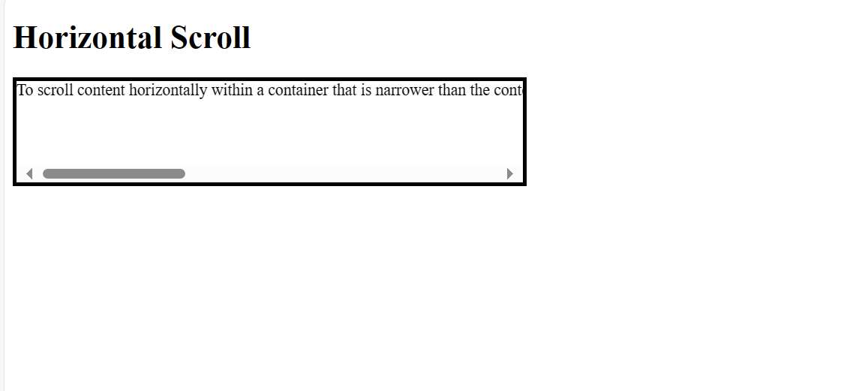

1. Create a progress bar using HTML and CSS.

**Program:**

<style>

        body{

            background-color: bisque;

        }

        progress{

            background-color: olivedrab;

        }

</style>

</head>

<body>

    <h1>Progress bar</h1>

    <progress value="80" max="100"></progress>

    <p>80% completed</p>

</body>

**Output:**

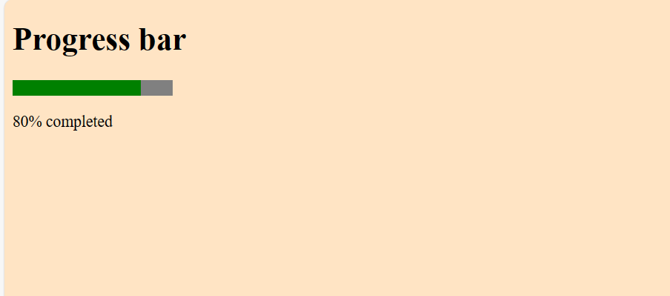

1. Implement a CSS animation on an element, such as a spinning effect.

**Program:**

<!DOCTYPE html>

<html>

    <head>

        <style>

            h1{

                color: orange;

            }

            div{

                width: 200px;

                height: 200px;

                border: 10px solid rgba(154, 61, 61, 0.155);

                border-radius: 50%;

                border-top: 10px solid rgb(68, 0, 255);

                animation: spin 2.5s linear infinite;

                margin-left: 50px;

            }

            @keyframes spin{

                0%{

                    transform:rotate(0deg);

                }

                100%{

                    transform:rotate(360deg);

                }

            }

        </style>

    </head>

    <body>

       <h1>Spinning</h1>

       <div>

       </div>

    </body>

</html>

**Output:**

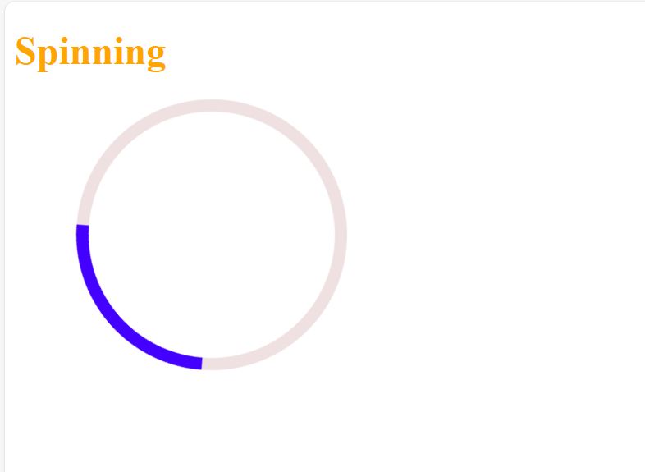

1. Build a tabbed content section using HTML, CSS, and JavaScript.

**Program:**

<!DOCTYPE html>

<html>

<head>

    <style>

        .container {

    border: 5px solid;

}

[data-tab-info] {

    display: none;

}

.active[data-tab-info] {

    display: block;

}

.tab-content {

    color: black;

}

.tabs {

    border-bottom: 2px solid;

    background-color: rgb(33, 197, 197);

    font-size: 25px;

    color: rgb(0, 0, 0);

    display: flex;

}

.tabs span {

    background: rgb(45, 210, 228);

    padding: 10px;

    border: 2px solid;

    margin: 3px;;

}

.tabs span:hover {

    background: rgb(189, 103, 189);

}

</style>

</head>

<body>

<div class="container">

<div class="tabs">

    <span data-tab-value="#tab_1">Tab A</span>

    <span data-tab-value="#tab_2">Tab B</span>

    <span data-tab-value="#tab_3">Tab C</span>

</div>

<div class="tab-content">

    <div class="tabs__tab active" id="tab_1" data-tab-info>

        <h3>HTML</h3>

        <p>HTML stands for HyperText Markup Language. <br>

            It is the standard language used to create and design web pages on the internet. <br>

            It was introduced by Tim Berners-Lee in 1991 at CERN as a simple markup language. </p>

    </div>

    <div class="tabs__tab" id="tab_2" data-tab-info>

        <h3>CSS</h3>

        <p>CSS, or Cascading Style Sheets, is the secret sauce that styles all the websites you visit. <br>

            It’s a simple language that controls how HTML elements (like text, images, and buttons) are displayed on a webpage. </p>

    </div>

    <div class="tabs__tab" id="tab_3" data-tab-info>

        <h3>JS</h3>

        <p>JavaScript is the most powerful and versatile programming language used in the web. <br>

           It is a commonly used programming language to create dynamic and interactive elements in web applications.</p>

    </div>

</div>

</div>

<script>

const tabs = document.querySelectorAll('[data-tab-value]')

const tabInfos = document.querySelectorAll('[data-tab-info]')

tabs.forEach(tab => {

    tab.addEventListener('click', () => {

        const target = document

            .querySelector(tab.dataset.tabValue);

        tabInfos.forEach(tabInfo => {

            tabInfo.classList.remove('active')

        })

        target.classList.add('active');

    })

})

</script>

</body>

</html>

**Output:**

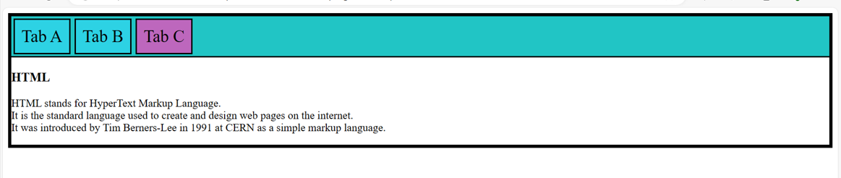

1. Design a responsive carousel/slider for showcasing images.

**Program:**

<!DOCTYPE html>

<html>

    <head>

        <style>

            img{

                width: 500px;

                height: 300px;

                border: 5px solid rgb(25, 198, 63);

                border-radius: 60px;

            }

        </style>

    </head>

    <body>

        <h2>Responsive slider for images</h2>

        <div>

            <img class="slide" src="Roseflower.jpg" alt="Image 1">

            <img class="slide" src="Charminar.jpg" alt="Image 2">

            <img class="slide" src="Buddha.jpg" alt="Image 3">

        </div>

            <p style="padding-left: 100px;">Automatic slideshow</p>

        <script>

            var myIndex = 0;

            carousel();

            function carousel() {

              var i;

              var x = document.getElementsByClassName("slide");

              for (i = 0; i < x.length; i++) {

                x[i].style.display = "none";

              }

              myIndex++;

              if (myIndex > x.length) {myIndex = 1}

              x[myIndex-1].style.display = "block";

              setTimeout(carousel, 2000); // Change image every 2 seconds

            }

        </script>

    </body>

</html>

**Output:**

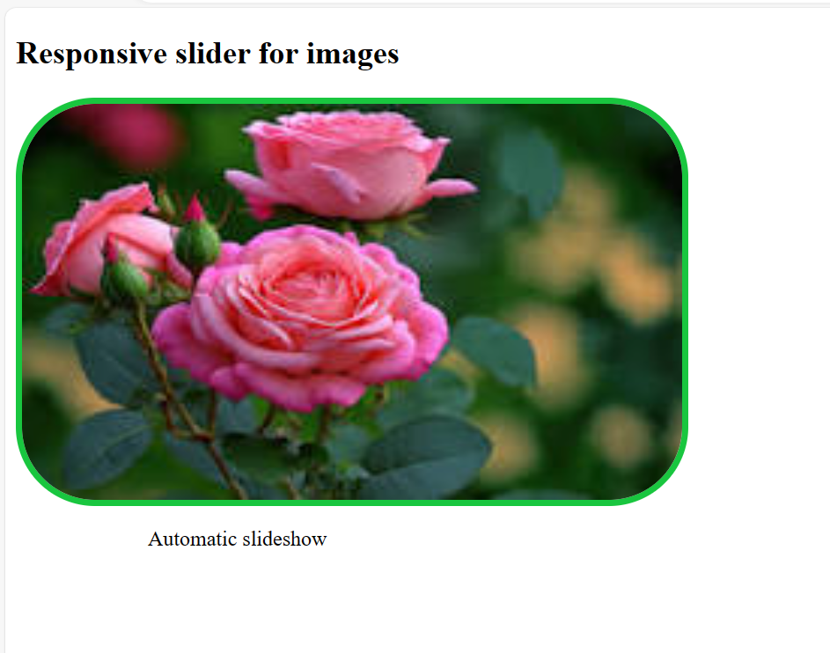

1. Style a list to have custom bullet points and spacing between items.

**Program:**

<style>

        body{

            background-color: bisque;

        }

        ul{

            background-color: lightpink;

            color: blue;

        }

        li{

            line-height: 30px;

        }

</style>

</head>

<body>

    <h1>List with bullets</h1>

    <ul>

        <li>Water-melon</li>

        <li>Mango</li>

        <li>Grapes</li>

    </ul>

</body>

**Output:**

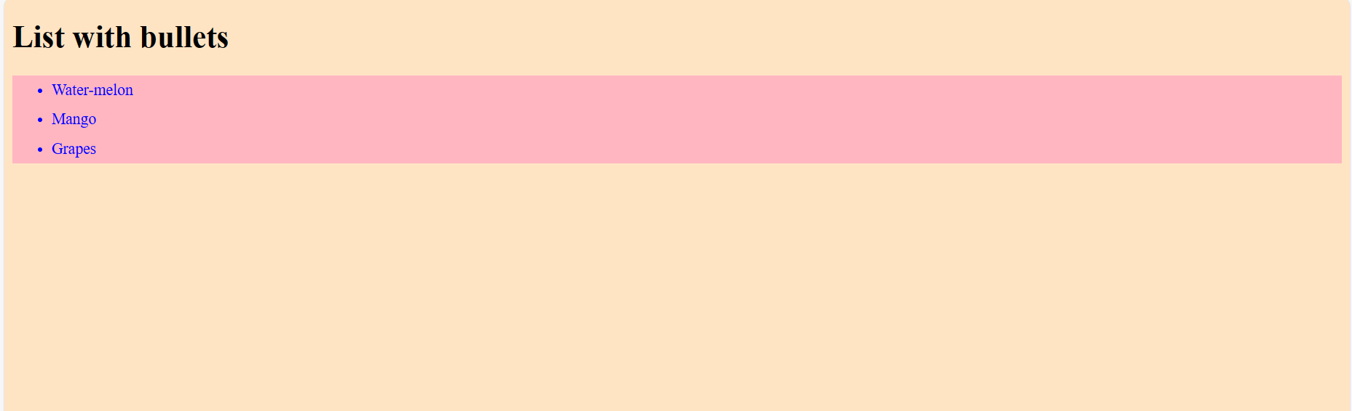

1. Make a website layout that uses a sticky sidebar.

**Program:**

<!DOCTYPE html>

<html>

    <head>

        <style>

            .main{

                display: flex;

                border: 2px solid;

                width: 300px;

                height: 200px;

            }

            .content{

                height: 200px;

                width: 200px;

                overflow: scroll;

                flex-direction: column;

                padding-left: 100px;

            }

            .sidebar{

                position: fixed;

                padding-left: 10px;

                background-color: rgb(139, 179, 238);

                height: 200px;

            }

            li{

                list-style: none;

            }

        </style>

    </head>

    <body>

       <h2>Sticky Sidebar</h2>

       <div class="main">

           <div class="content">

               <h4>Key Features of JavaScript:</h4>

               <p>

                   Versatility: JavaScript can be used to develop websites, games, mobile apps, and more. <br><br>

                   Client and Server-Side: With frameworks like Node.js and Express.js, JavaScript is now used for building server-side applications. <br><br>

                   End-to-End Solutions: JavaScript enables developers to create complete solutions for various problems. <br><br>

                   Constant Evolution: JavaScript continually evolves with new features and standards. <br><br>

                   Vibrant Community: A large community of users and mentors actively contributes to JavaScript’s growth.

                </p>

            </div>

                <div class="sidebar">

                    <h4>Sidebar</h4>

                        <li>Home</li>

                        <li>About</li>

                        <li>Products</li>

                        <li>Contact Us</li>

                </div>

        </div>

    </body>

</html>

**Output:**

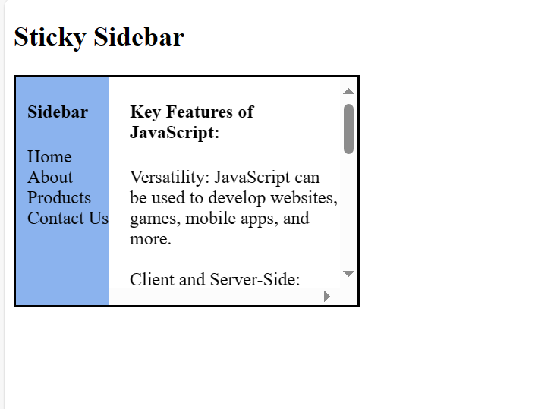

1. Create a simple tooltip using HTML and CSS.

**Program:**

<style>

        body{

            background-color: bisque;

        }

        button{

            background-color: rgb(231, 239, 115);

            cursor: pointer;

            font-weight: bold;

        }

    </style>

</head>

<body>

    <h1>Tooltip</h1>

    <p>This is a Tooltip and hover mouse on button to see tooltip.</p>

    <button title="tooltip">Hover me</button>

</body>

**Output:**

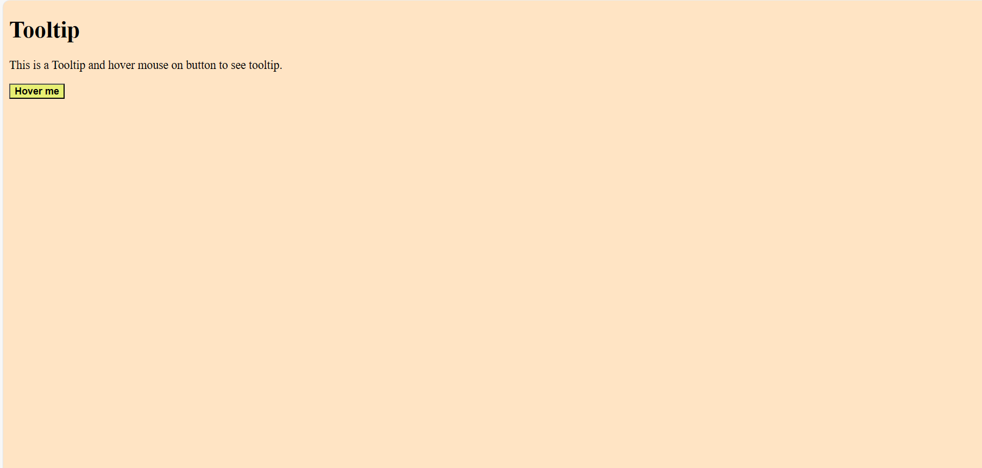

1. Design a card layout for displaying content with an image, title, and description.

**Program:**

<!DOCTYPE html>

<html>

    <head>

        <style>

            img{

                height: 100px;

                width: 200px;

                border: 2px;

                border-radius: 5px;

            }

            .card{

                border: 2px solid black;

                border-radius: 30px;

                height: 220px;

                width: 200px;

                margin: 20px;

                margin-top: 100px;

                padding: 10px;

                background-color:rgb(150, 207, 229);

            }

            body{

                display: flex;

            }

        </style>

    </head>

    <body>

       <h1>Card Layout</h1>

        <div class="card">

            <img src="Buddha.jpg" alt="Image 1">

            <h2>Buddha</h2>

            <p>The Buddha Statue of Hyderabad is a monolith located in India.</p>

            <p>It is the world's tallest monolith of Gautama Buddha.</p>

        </div>

        <div class="card">

            <img src="Charminar.jpg" alt="Image 2">

            <h2>Charminar</h2>

            <p>Charminar was built by Sultan Mohammed Quli Qutb Shah in 1591.</p>

            <p>The Charminar is a monument and mosque in Hyderabad, India.</p>

        </div>

    </body>

</html>

**Output:**

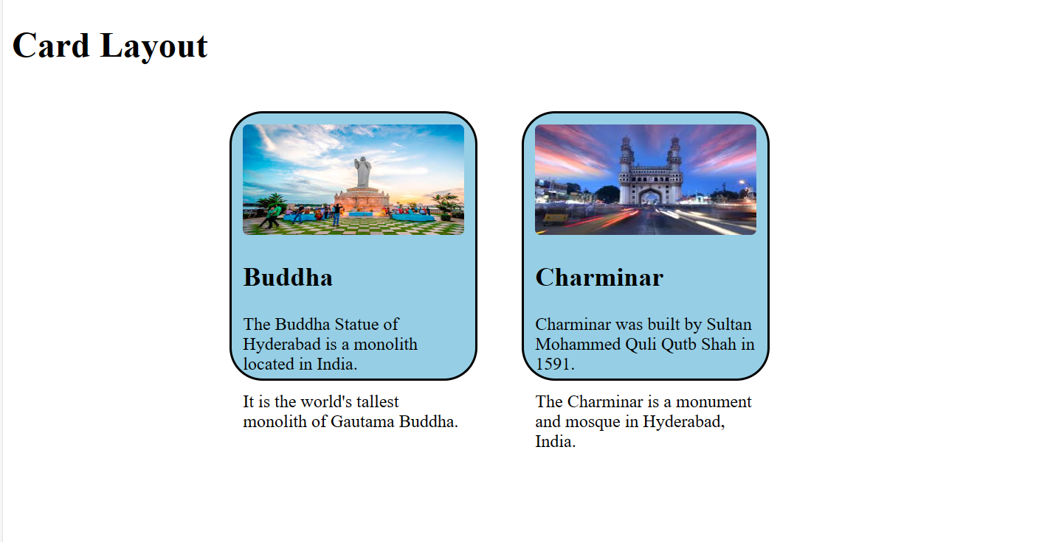

1. Implement a CSS transition on a button to change color smoothly.

**Program:**

<style>

        button{

            background-color: greenyellow;

            font-weight: bold;

            cursor: pointer;

            transition-duration: 5s;

            transition: background-color 3s;

        }

        button:hover{

            background-color: rgb(218, 27, 34);

        }

 </style>

</head>

<body>

    <h1>Transition color</h1>

    <p>Hover button to see yellow color</p>

    <button>Button</button>

</body>

**Output:**

**Before Hover:**

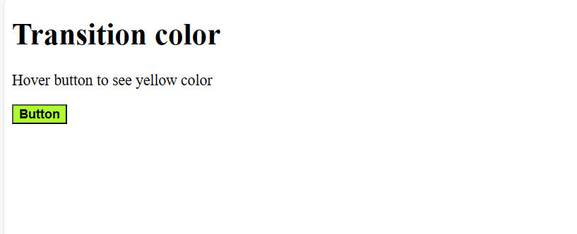

**After Hover:**

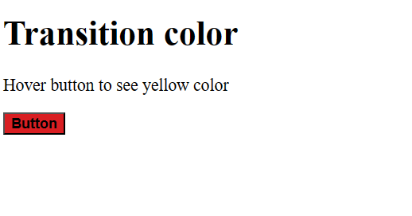

1. Build a responsive navbar with a hamburger menu for mobile devices.

**Program:**

<!DOCTYPE html>

<html>

<head>

<meta name="viewport" content="width=device-width, initial-scale=1">

<link rel="stylesheet" href="https://cdnjs.cloudflare.com/ajax/libs/font-awesome/4.7.0/css/font-awesome.min.css">

<style>

.container {

  width: 300px;

  margin: auto;

  background-color: #555;

  height: 400px;

  color: white;

}

.topnav {

  background-color: #e3b317;

  position: relative;

}

.topnav #items {

  display: none;

}

.topnav a {

  color: white;

  padding: 14px 16px;

  display: block;

}

.topnav a.icon {

  background: black;

  display: block;

  position: absolute;

  right: 0;

  top: 0;

}

.topnav a:hover {

  background-color: #993a3a;

  color: black;

}

</style>

</head>

<body>

    <h2 style="text-align: center;">Nav bar with hamburger menu</h2>

<div class="container">

<div class="topnav">

  <a href="#Home">Home</a>

  <div id="items">

    <a href="#About">About</a>

    <a href="#Products">Products</a>

    <a href="#Contact">Contact</a>

  </div>

  <a href="javascript:void(0);" class="icon" onclick="myFunction()">

    <i class="fa fa-bars"></i>

  </a>

</div>

<div style="padding-left:16px">

  <h3>Hamburger menu</h3>

  <p>Click on the menu bar to see the items!</p>

  <p>This is responsive nav bar for mobile devices.</p>

</div>

</div>

<script>

function myFunction() {

  var x = document.getElementById("items");

  if (x.style.display === "block") {

    x.style.display = "none";

  } else {

    x.style.display = "block";

  }

}

</script>

</body>

</html>

**Output:**

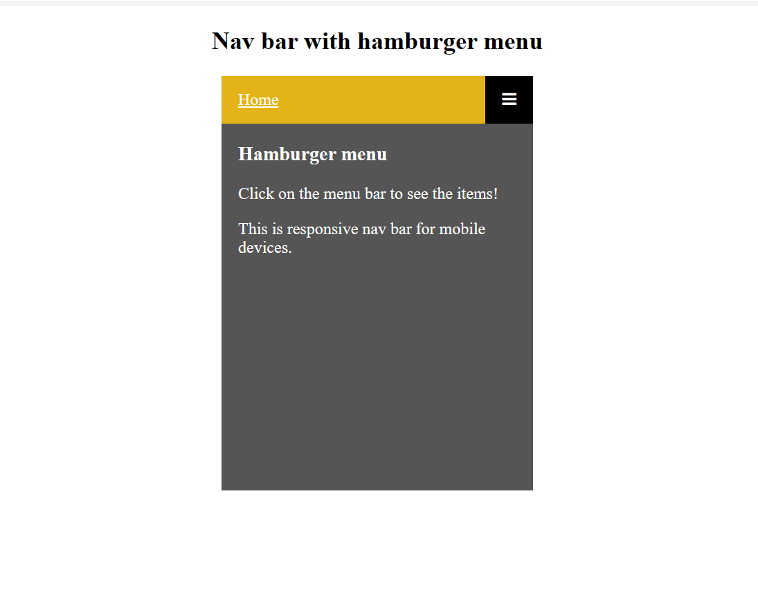

1. Style a table to have alternating row colors and a hover effect on rows.

**Program:**

<!DOCTYPE html>

<html>

    <head>

        <style>

            table{

                border: 3px solid orange;

                border-radius: 10px;

                height: 300px;

                width: 400px;

            }

            th,td{

                border: 2px solid;

            }

            .color1{

                background-color: rgb(68, 186, 64);

            }

            .color2{

                background-color: deepskyblue;

            }

            tr:hover{

                background-color: red;

                cursor: pointer;

            }

        </style>

    </head>

    <body>

        <h2>Employee Table</h2>

        <table>

            <th>Employee Name</th>

            <th>Employee salary</th>

            <th>Employee Address</th>

            <tr class="color1">

                <td>Emp1</td>

                <td>20k</td>

                <td>Hyderabad</td>

            </tr>

            <tr class="color2">

                <td>Emp2</td>

                <td>30k</td>

                <td>Bangalore</td>

            </tr>

            <tr class="color1">

                <td>Emp3</td>

                <td>45k</td>

                <td>chennai</td>

            </tr>

        </table>

    </body>

</html>

**Output:**

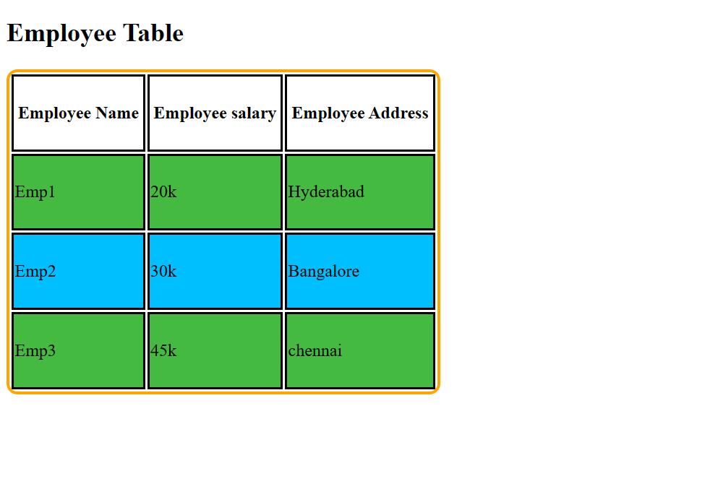

1. Design a progress tracker with steps using HTML and CSS.

**Program:**

<!DOCTYPE html>

<html>

    <head>

        <style>

            progress{

                border: 4px solid;

                border-radius: 6px;

                width: 400px;

                height: 50px;

                background-color: rgb(149, 212, 85);

            }

        </style>

    </head>

    <body>

       <h1>Progress Tracker</h1>

       <progress value="90" max="100"></progress>

        <p>90% completed</p>

    </body>

</html>

**Output:**

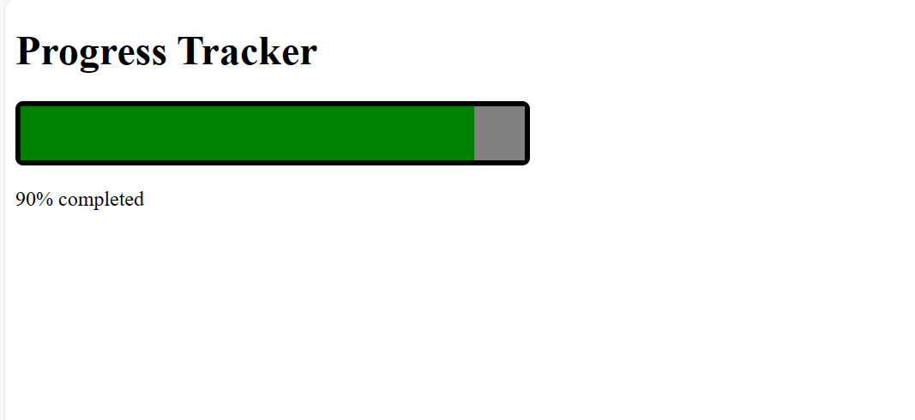

1. Create a parallax scrolling effect on a webpage background.

**Program:**

<!DOCTYPE html>

<html>

    <head>

        <style>

            .main{

                border: 2px solid;

                width: 600px;

                min-height: 700px;

            }

            .parx1{

                background-image: url(Buddha.jpg);

                background-attachment: fixed;

                background-position: center;

                background-repeat: no-repeat;

                background-size: cover;

                height: 200px;

            }

            .parx2{

                background-image: url(Buddha.jpg);

                background-position: center;

                background-repeat: no-repeat;

                background-attachment: fixed;

                background-size: cover;

                height: 500px;

            }

            div{

                background-color: rgb(220, 135, 23);

                height: 200px;

            }

            </style>

    </head>

    <body>

       <h2>Parallax Scrolling Effect</h2>

       <div class="main">

           <div class="parx1"></div>

           <div>

               <h2>Hyderabad</h2>

               <p>Hyderabad is a city in the southern part of India, located in the state of Telangana. It is known for its rich history, culture, and architecture.

                One of the most famous landmarks in Hyderabad is the Charminar, a 16th-century mosque with four grand arches, located in the heart of the old city.

                The city is home to many historical sites and monuments, including the Golconda Fort<</p>

            </div>

            <div class="parx2"></div>

        </div>

    </body>

</html>

**Output:**

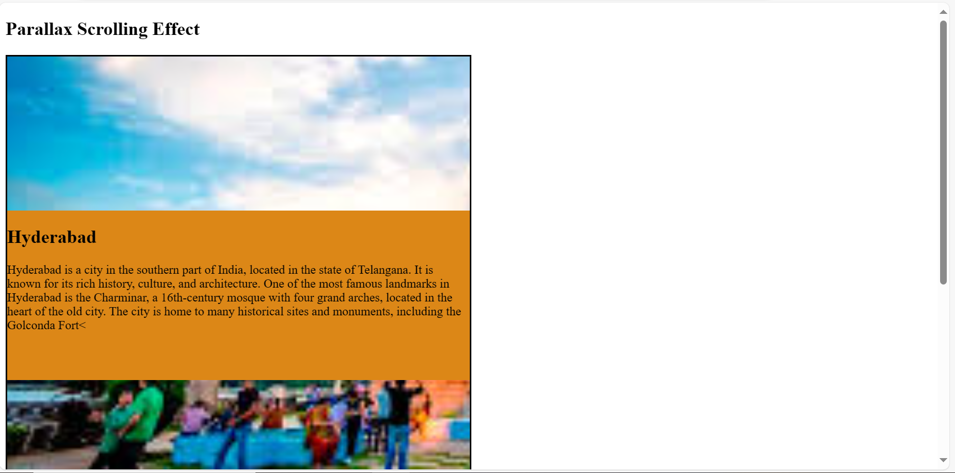

1. Build a dropdown select menu with options styled using CSS

**Program:**

<style>

        body{

          background-color: lightgray;

        }

        .Country{

          background-color: lightcoral;

        }

        input{

          background-color: rgb(193, 227, 124);

          cursor: pointer;

        }

        option{

            color: rgb(43, 183, 55);

            font-weight: bold;

        }

</style>

  </head>

  <body>

      <h1>Dropdown-menu</h1>

      <select class="Country" name="Country" id="Country">

          <option value="India">India</option>

          <option value="China">China</option>

          <option value="Nepal">Nepal</option>

          <option value="America">America</option>

          </div>

      </select>

      <input type="Submit" value="Submit">

  </body>

**Output:**

